Physical Therapy:

Gross Motor Skills: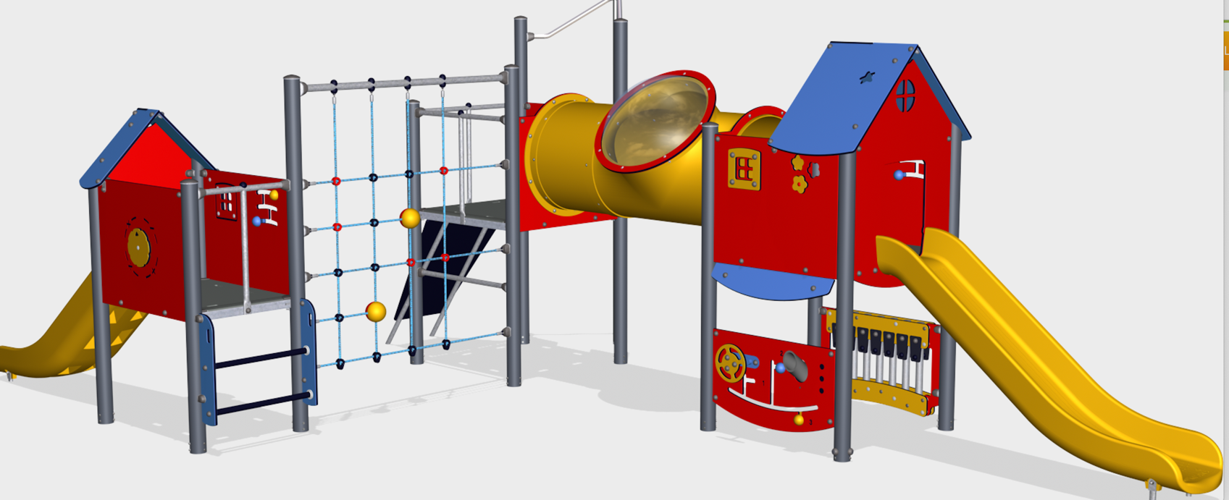

Home Practice:
- Make a hopscotch course with chalk.
- Use the chalk to make an obstacle course for bikes, scooters, etc.
- Take a trip to the playground: Go down the slide, swing on the swings, and go through any tunnels.
- Set up empty milk cartons or cereal boxes and use them as bowling pins to roll a ball to.
- Take a walk around the park, beach, or your neighborhood with your family.
- “Insect Walk” – Ask children to walk all kinds of ways. “Slowly as a snail. Quickly as a spider. Wiggly as a worm. Stop and go like a beetle.”
- Bring a ball to the playground. Throw the ball to work on arm strength and coordination.
- Practice going up and down the stairs with an adult. This helps to build leg strength.

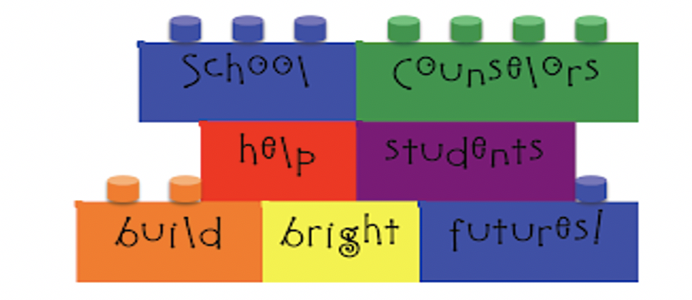

School counseling program vision:
At p.s.86 we are committed to creating an inclusive climate of trust and community. this is done through collaborations with all stakeholders involved. We pride ourselves on the relationships we invest in and build on with the students and their families and our staff. We believe students relationships are fundamental to success. When students feel supported, they’re more likely to engage in learning and have better social and academic outcomes.

My name is Barbara Korzekwinski. I am the School Counselor at P.S.86Q. I am also known as Mrs. K. I wear many hats at P.S.86Q. I can be reached at bkorzek@schools.nyc.gov .



Parents sign-up for the emails as they send excellent tips and strategies:
https://www.understood.org/pages/en/families/?_sp=2cbf5964-8291-45b1-bd59-756073a24312.1620751851002
Project New Yorker – Improve the livelihood of under-resourced women and youth:
https://www.projectnewyorker.org/
The Einstein Program – A free and privately funded tutoring and educational service:
https://www.einsteinprogram.org/

